Ternia Wilson
2/6/2020

Specification for Computer

1. The brand of CPU (Intel or AMD)
Intel

2. The number of cores on CPU
4

3. The clock rate of CPU in GHz
2.9 GHz

4. The amount of memory in GB
16 GB

5. The speed of memory (for example: DDR4 3200)
2.9 GHz, 16 GB 2133 MHz LPDDR3

6. The capacity of hard drive
499.96 GB (499,963,170,816 bytes)/500 GB

7. The model of CPU (e.g. Intel i7-9700K Coffee Lake)
Intel Core i7

8. The type of hard drive: SSD
-For SSD, provide
-Max sequential read speed
475 MB/s
-Max sequential write speed
446 MB/s
-Max random read speed
508 MB/s
-Max random write speed
493 MB/s

9. One screenshot for each of the benchmark showing the output of the benchmark:
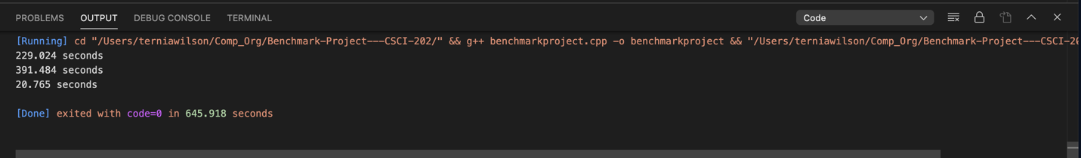

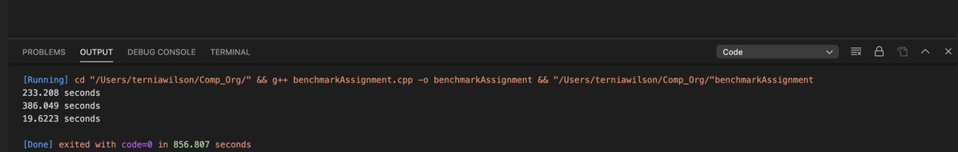

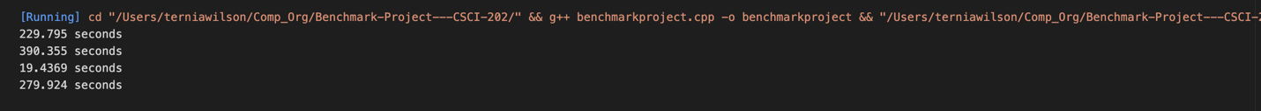
Caption:
Benchmark 1 through 3 were ran, alone, twice, the outputs are above. Benchmark 4 was ran twice along with benchmarks 1 through 3.

10. A table recording the results of all the benchmarks:
 | Benchmark 1 | Benchmark 2 | Benchmark 3 | Benchmark 4
Execution Time | 229.795 s | 390.355 s | 19.4369 s | 279.924 s
Reference Time | 100 s | 500 s | 100 s | 1000 s
Spec Ratio | .4351704780 | 1.28088535 | 5.14485335 | 3.57239822

11. The calculation of a single number to summarize the results of all four benchmarks:
26.0832684858

((100 ÷ 229.795) + (500 ÷ 390.355) + (100 ÷ 19.4369) + (1000 ÷ 279.924)) = 10.4333073943
10.4333073943 ÷ 4 = 2.60832684858
2.60832684858 ÷ (100 ÷ 1000) = 26.0832684858

